Software is a collection of instructions, data, or computer programs that are used to run machines and carry out particular activities. It is the antithesis of hardware, which refers to a computer’s external components. A device’s running programs, scripts, and applications are collectively referred to as “software” in this context.

What is a Software?

In a computer system, the software is basically a set of instructions or commands that tell a computer what to do. In other words, the software is a computer program that provides a set of instructions to execute a user’s commands and tell the computer what to do. For example like MS-Word, MS-Excel, PowerPoint, etc.

Types of Software
It is a collection of data that is given to the computer to complete a particular task. The chart below describes the types of software:
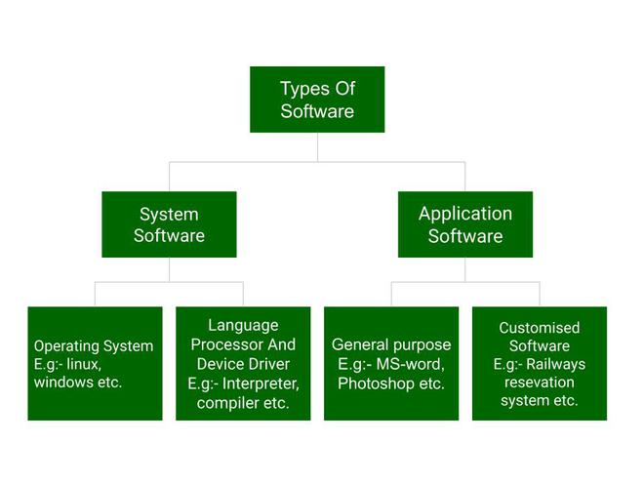
Above is the diagram of types of software. Now we will briefly describe each type and its subtypes:
- System Software
  - Operating System
  - Language Processor
  - Device Driver
- Application Software
  - General Purpose Software
  - Customize Software
  - Utility Software

- . Project :
Also known as a software project comprises the steps involved in making a product before it is actually available to the market. The project can be handled by people which are as less as one person to the involvement of a lot of people (over 100). These are usually assigned by an enterprise and are undertaken to form a new product that has not already been made. Example is hotel management system, employee management system .

2. Product :
The study of products is a part of Software engineering. The software is built by developers on requests from the customer. After the customer is satisfied with the development process, he launches the software by manufacturing it. This can be a problem-solving software or computer based system. This is the result of a project. The software project, when completed, is called a product after it is available to the market for usage.example is flipkart , amazon , facebook etc .
S.NO. | Project | Product
1. | It comprises the steps involved in making a software before it is actually available to the market. | It is the manufacture of the project for users.
2. | The main goal of a project is to form a new product that has not already been made. | The main goal of the product is to complete the work successfully (solve a specific problem).
3. | Project is undertaken to form a new software. | Product is the final production of the project.
4. | It focuses on increasing the performance of the software that is being built. | A product focuses on the final result and the efficiency with which it can solve the given problem.
5. | A project is done only once to get a new software. | A product can be made again and again for the purpose of distribution among users.
6. | It is more risky as here, a software is being made for the first time. | It is relatively less risky as the software has already been made and tested. The only risk in most cases would be of wear and tear.
7. | It is handled by the project managers. | It is handled by the product managers.
8. | It exists before the software is made. | It exists after the completion of the software development phases.
9. | It has some cost barriers as the enterprise sets a fixed budget for the project. | It has no cost barrier as it is continued to be developed only as long as the distributing enterprise is profitable.
10. | Project is based on Predictive planning (up-front). | The product is based on adaptive planning (iterative).

